IPhone Setup with GUtech Email for Student

Step 1
From the home screen, select Settings. Then select Mail, Contacts, Calendars.
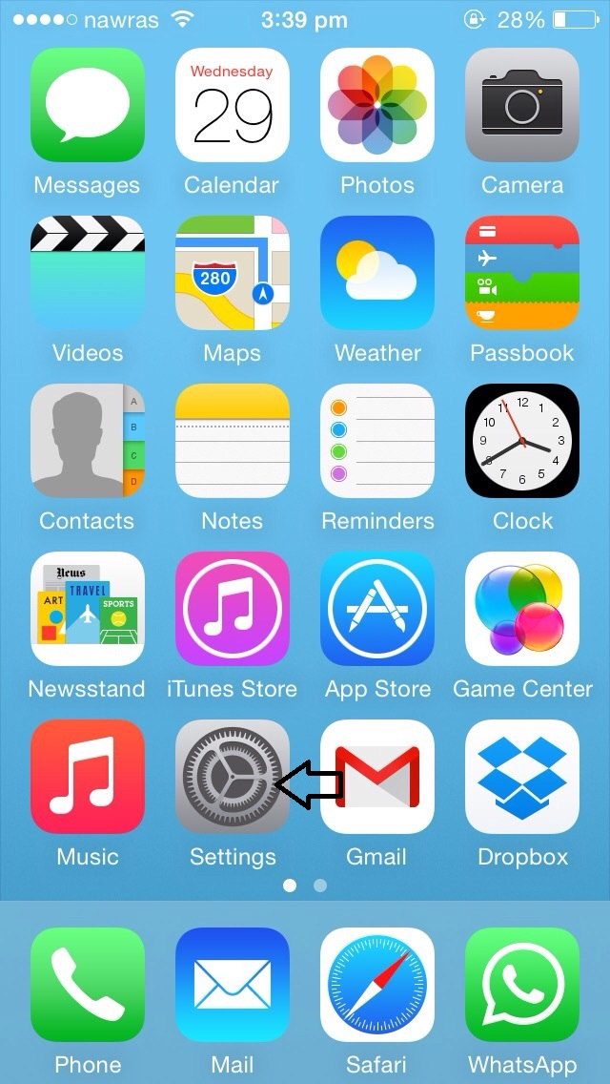
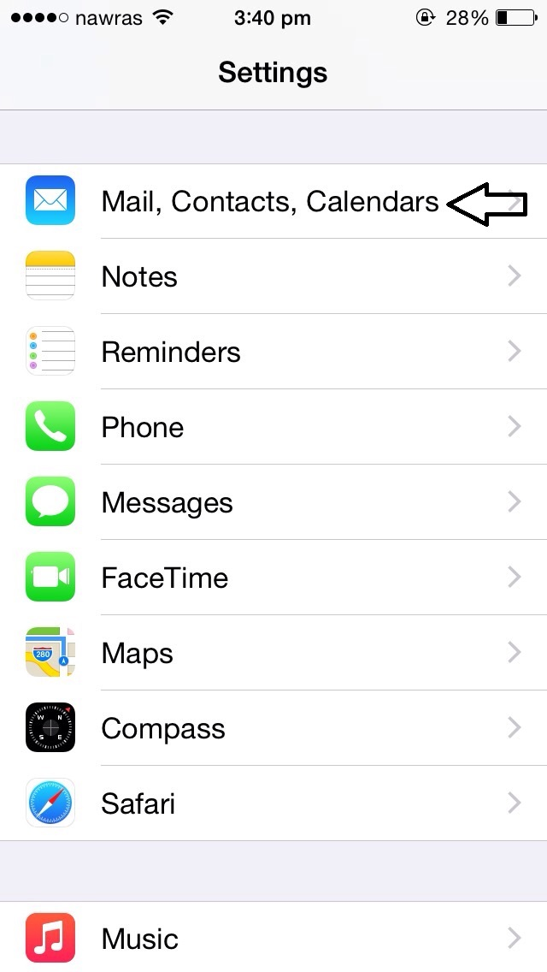
Step 2
Select Exchange.

Step 3
Select Add Account. This step is skipped if this is the first email account on the phone.

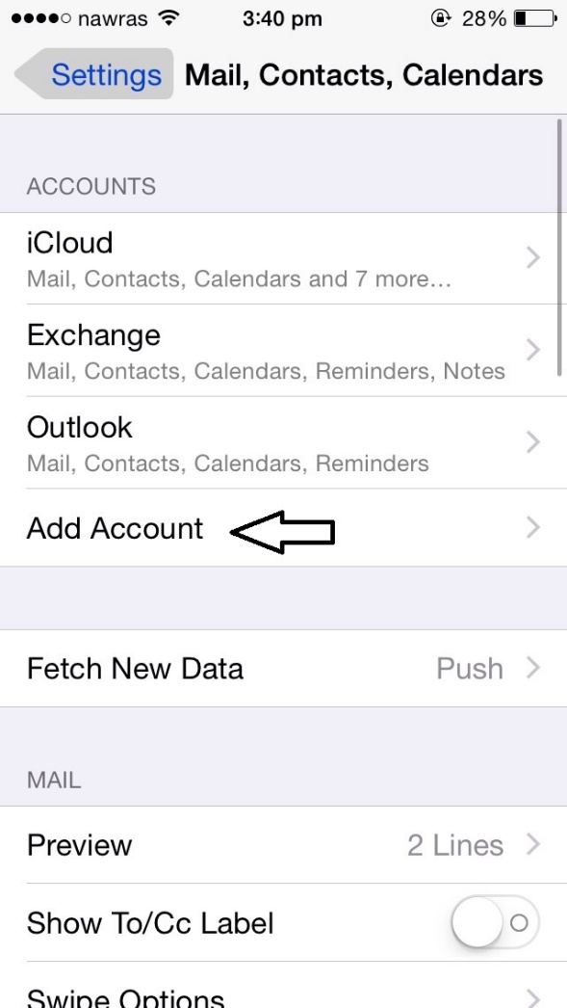
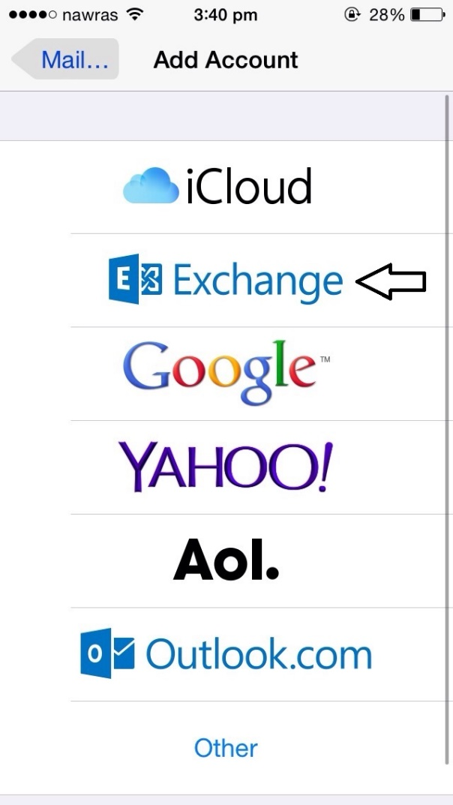

Step Four
In the Email field, enter your full email
Address (for example, 00-0000@student.gutech.edu.om).
In the Password field, enter the same password used for your email.
In the Description field, enter GUtech (Optional)
Click Next
. 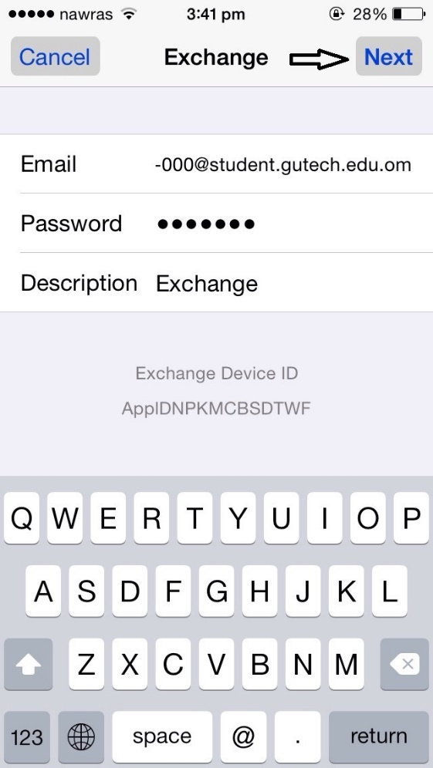

Step Five
In the Server field, enter "outlook.office365.com" (without quotes).
Click Next.
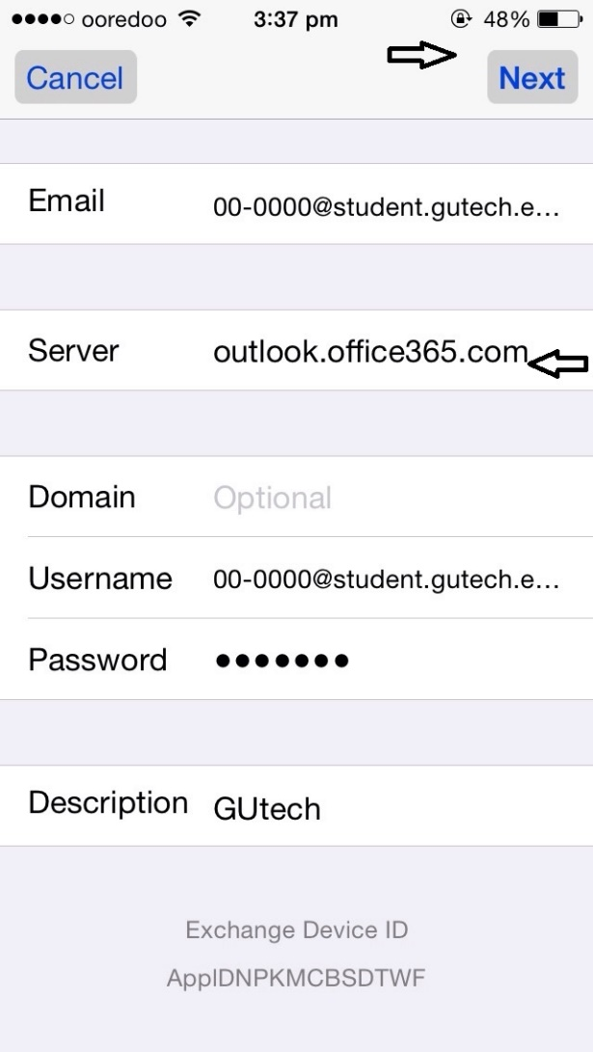

Step Six
Choose which options you'd like synchronized.
Click Save.

