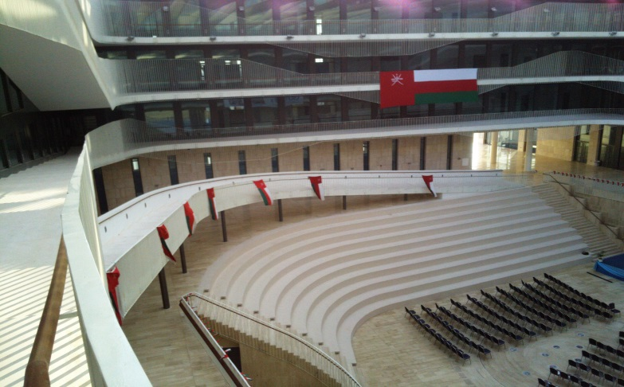

Before you call an IT staff,

You may please go through this manual. If you still need support, Visit IT support helpdesk.

Or Email: [IThelpdesk@gutech.edu.om](mailto:ithelpdesk@gutech.edu.om)

User manual for authorized users



**What do we do ?**

* Maintaining User and computer accounts.
* Internet facilities & access to computing facilities
* Email - access to Email services
* PC Maintenance - providing build and repair services for hardware
* Training Courses - IT courses for employees
* Advanced Computing – Support to advanced computing expertise, services and facilities for research and teaching
* Remote Access - access to the University networks off campus
* Software Applications - documentation and support for software applications
* Telecoms - providing campus-wide telecommunications
* IT pool - Laptops, projectors and many other accessories on loan
* File Storage - provide data storage for users
* Security & Virus Protection - advise on how to protect computer and data
* Videoconferencing - video conferencing facilities for staff
* Wireless - secure wireless connection
* Guest Internet access
* EDUROAM wireless
* Printing - general printing from PC and specialist printing facilities
* Scanning, plotting and copying
* Portal support (ERP-self-service portal, Q-WiKi, etc)
* Website technical administration

Location :

Floor 2=tech Administration Wing

Phone : (968) 22061088, 89

PB-1816, PC-130

Sultanate of Oman

Table of Contents

[Accounts and Access 3](#_Toc428966218)

[User credentials and password management 5](#_Toc428966219)

[Communication Infrastructure at GUtech (Internet) 5](#_Toc428966220)

[Communication Infrastructure at GUtech (Voice) 7](#_Toc428966221)

[E mail system at GUtech. 8](#_Toc428966222)

[ERP (Enterprise Resources Planning) 12](#_Toc428966223)

[Staff/ Student ID card 13](#_Toc428966224)

[IT STAFF 14](#_Toc428966226)

[Website, ERP and Portals along with their functions 17](#_Toc428966227)

[GUtech’s Enterprise resource planning (ERP) System 18](#_Toc428966228)

[Appendix 1: Mobile phone configurations 29](#_Toc428966229)

[Appendix 2: Telephone Directory / Email of GUtech staff (Reference from HR system): 37](#_Toc428966230)

# Accounts and Access

To access GUtech computers, Email, Files, Portals, a User should have a ‘GUtech user account’ and a password, provided by IT Service department of GUtech.

# User credentials and password management

**Applying for an GUtech account**

A staff or a student can get an account for accessing IT resources at GUtech.

We do not take direct applications for creating an account. A staff member has to approach ITS through Human Recourses department. A student gets an account once enrolled in the university and account activation instructions will be part of welcome kit given by Student Affairs Department.

ITS also provides short term accounts (up to 6 months) for Interns who visit and work with GUtech’ s Academic or Admin departments, provided the application to ITS comes from HR department.

**Guest account**

A guest account may be provided for a visitor to GUtech for internet access but such applications should be handed over to ITS in advance through Department Head. Guest account is issued for a short duration varying from 1 day to 3 months. User name and password for Guest will provide by HOD of each department

**GUtech Account Activation:**

1. Go to **https://outlook.office365.com/** OR [**http://aka.ms/ssprsetup**](http://aka.ms/ssprsetup)
2. Enter your GUtech Email ID and password.
3. Choose an option to register for by clicking **set it up now** for Email and Phone.
4. Please enter your Mobile Number and Alternative email for verification.
5. Then follow the instructions and logout after Setting Email and Password Authentication.

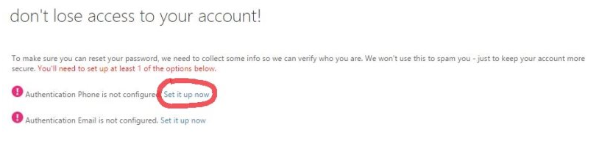

**Steps to Reset your Password.**

1. On GUtech Email account sign-in page, click on one of the "can't access your account?" or "forgot your password?" links, or navigate to [**https://passwordreset.microsoftonline.com**](https://passwordreset.microsoftonline.com) directly.
2. Enter your GUtech Email ID and Captcha correctly

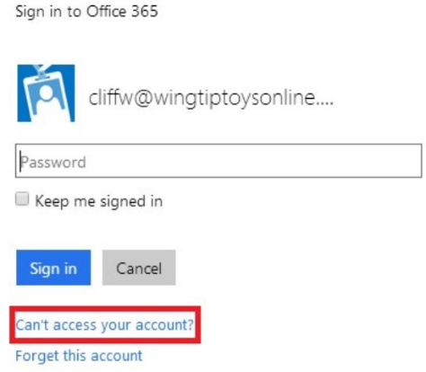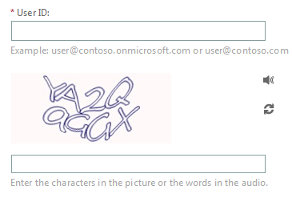

1. Follow the one verification methods which you prefer. Once you’ve met the requirements of the organizational policy, you are allowed to choose a new password.

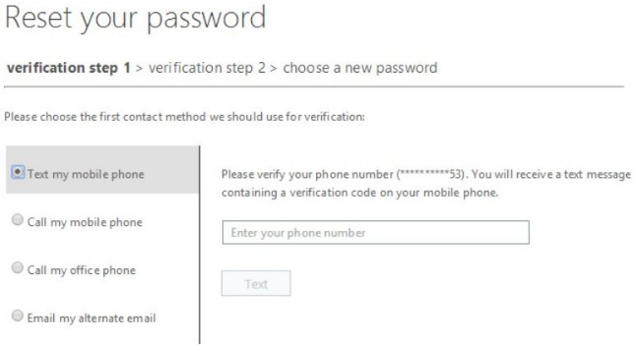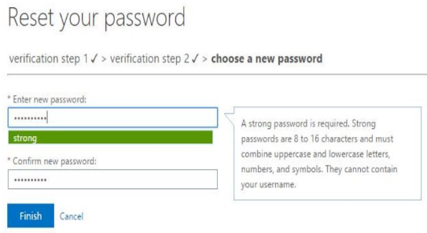

1. After successful password reset you can login to all GUtech IT Portals with the new password.

# Networks, Control and Connectivity

All GUtech users those who have active user accounts are eligible for accessing internet and ERP portals of GUtech.

They can use their Username and password to login.

**Wi-Fi and SSIDs**

Users can connect to “GUtech” SSID and based on their affiliation the access roles will be defined automatically. Authorized users are eligible to get a VPN connection to GUtech on request.

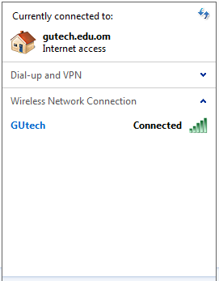

Visit IT helpdesk for installation and configuration setups.

**eduroam_logo_trans.gifEduroam**

**(Applicable only if you have a VPN account with Aachen)**

Eduroam WLAN access can be used worldwide at all research facilities which are connected to [eduroam](http://www.rz.rwth-aachen.de/eduroam). VPN is not needed in this network. Eduroam is not administered by GUtech. Users should contact Aachen service desk for support.

**General settings of Eduroam:**

|  |  |
| --- | --- |
| SSID: | **eduroam** at infrastructure mode |
| Authentication: | **WPA2** (alternative: WPA\*) |
| 802.1x: | **activated** |
| Encryption: | **AES** |
| Authentication type: | **TTLS** (alternative: PEAP\*\*) |
| Authentication protocol: | **PAP** (alternative: MsCHAPv2\*\*) |
| User name: | WLAN/VPN account according to [TIM](http://www.rz.rwth-aachen.de/go/id/ocw/) |
| Domain: | **rwth-aachen.de**  (alternative: Domain can remain empty and enter the user name with the following format: **USERID@rwth-aachen.de**) |
| Roaming identity: | **USERID@rwth-aachen.de** |
| Server certificate: | **validate** The following [3 certificates](http://www.rz.rwth-aachen.de/li/c/soj/lang/de/) must be installed:  Telekom Toplevel Certificate, DFN-Global Certificate and the RWTH Certificate.(A connection without validation is possible, but not recommend) |
| Root certificate: | **coded connection to the mail server**  You need to install the DFN certificate and the RWTH certificate.Installapplication: [rootcertificates](http://www.rz.rwth-aachen.de/aw/cms/rz/Themen/unsere_dienste/kommunikation/Infodienste/webmail/anleitungen/wurzelzertifikat_im_emailprogramm_instal/~rvn/installation_des_wurzelzertifikats_in_wi/?lang=en) |

**RWTH Aachen VPN connection help:**

A staff member can apply for VPN to RWTH Aachen for accessing E library or similar sources based on the current affiliation. To apply, you can print the duly filled form and submit to HoD of ITS.

**Form available at** : <http://qwiki.gutech.edu.om/pub/ITServices/Staff/VPNRequestform/VPN_Request_form.pdf>

**Help file to connect VPN** : <http://www.rz.rwth-aachen.de/aw/cms/rz/Themen/unsere_dienste/kommunikation/netzbetrieb/dienste/vpn/~pkl/installation/?lang=en>

# Communication Infrastructure at GUtech (Voice)

**Phone directory available in the last page**

**Telephone and CISCO Unified communication system**

As a member of the GUtech you can access voice network accessible from specified offices.

ITS provide VOIP phones to Departments. Telephones are provided to a staff based on HoD’s request. In most cases, a telephone in a particular office is being shared. International call facility is not approved by default, to any office. Please contact HoD of Finance for details to avail ISD facility for an office.

Primary Telephone Number: +968-2206 1111

**Fax**

Five fax lines have been deployed at GUtech. GUtech’s copy center (first floor) provides fax services for end users.

**Primary Fax Number: +968-2206 1000**

**Admin Fax Number : +968-2206 1002**

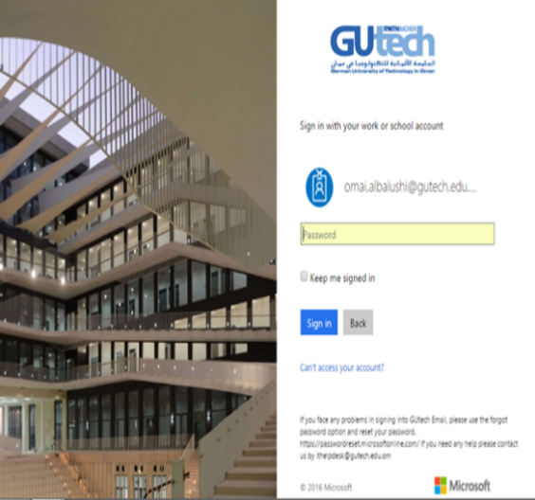

# Office 365 and E mail system at GUtech.

**Office 365**

Office 365 is a cloud-based email and calendaring service, hosted by Microsoft. All University staff and students receive free email accounts.

**Mail Access**

Mails can be accessed either through office 365 portal <https://login.microsoftonline.com/>

First time users of web mail, please note that the Time zone to be set as “UTC+4:00 Abu Dhabi, Muscat”.

You can also use a desktop email client (Microsoft outlook) or a mobile device to access your Office 365 email and calendar.

**Features**

50 GB of email storage

Up to 150 MB email file size (25 MB per file attachment)

**Student Email System**

Student emails are hosted with Office 365 for Education ® at Microsoft cloud services. You should get a username and password from ITS to access emails and portals of Office 365.

1. In Office 365, to access your email, click **Outlook** at the top of the page.   
     
   Or, you can go directly to your email at any of the following URLs:
   * 1. <https://www.outlook.com/student.gutech.edu.om>
2. Sign in to your personal Microsoft account at  [https://onedrive.live.com/](https://skydrive.live.com/) , using the same user name and password you used with Office365.
   * 1. This is now a personal account for you, which means that your educational institution's administrator can no longer reset the password.
     2. You can change the password on this account whenever you want to.
   * This account gives you access to all your SkyDrive content and other Microsoft services such as Messenger.
   * If you need help with this account, see [Microsoft account help](http://go.microsoft.com/fwlink/p/?LinkId=259650).

**How do I set up Microsoft Exchange email on an Apple iPhone, iPad or iPod Touch?**

**(For GUtech students only)**

1. Tap **Settings** > **Mail, Contacts, Calendars** > **Add Account**.
2. Tap **Microsoft Exchange**.
3. You don’t need to enter anything in the **Domain** box. Enter the information requested in the **Email**, **Username**, and **Password** boxes. You need to enter your full e-mail address in the **Email** and **Username** boxes
   1. For example:
   2. Email address : <Student-ID>@student.gutech.edu.om
   3. Username : <Student-ID>
   4. Password : xxxxxxxxx
4. Tap **Next** on the upper-right corner of the screen. Your iPhone will try to find the settings it needs to set up your account.
5. Choose the type of information you want to synchronize between your account and your device, and then touch **Save**. By default, Mail, Contacts, and Calendar information are synchronized.

**How do I set up Exchange ActiveSync on an Android mobile phone?**

**(for GUtech students only)**

1. From the **Applications** menu, select **Email**.
2. Type your full email address, for example <student-ID@student.gutech.edu.om, and your password, and then select **Next**.
3. Select **Microsoft Exchange ActiveSync**. This option may be named Exchange ActiveSync on some versions of Android.
4. Enter the following account information and select **Next**.
   1. **Domain\Username** Type your full email address in this box. If **Domain** and **Username** are separate text boxes in your version of Android, leave the **Domain** box empty and type your full email address in the **Username** box.
   2. **Password** Use the password that you use to access your account.
   3. **Exchange Server** Use the address of your Exchange server. To find this address, see “Finding the Server Name” later in this topic.
   4. For example:
   5. Domain\Username : <Student-ID>@student.gutech.edu.om
   6. Username : <Student-ID>

Exchange Server : <http://mail.office365.com/>

1. As soon as your phone verifies the server settings, the **Account Options** screen displays. The options available depend on the version of Android on your device. The options may include the following:
   1. **Email checking frequency** The default value is Automatic (push). When you select this option, email messages will be sent to your phone as they arrive. We recommend only selecting this option if you have an unlimited data plan.
   2. **Amount to synchronise** This is the amount of mail you want to keep on your mobile phone. You can choose from several length options, including One day, Three days and One week.
   3. **Notify me when email arrives** If you select this option, your mobile phone will notify you when you receive a new email message.
   4. **Sync contacts from this account** If you select this option, your contacts will be synchronized between your phone and your account.
2. Select **Next** and then type a name for this account and the name you want displayed when you send email to others. Select **Done** to complete the email setup and start using your account.

# Appendix 1: Mobile phone configurations

**How do I set up GUtech Exchange ActiveSync on an Apple Mobiles**

1. Tap **Settings** > **Mail, Contacts, Calendars** > **Add Account**.

**IPhone Setup with GUtech Email for Student**

**Step 1**

From the home screen, select Settings. Then select Mail, Contacts, and Calendars.

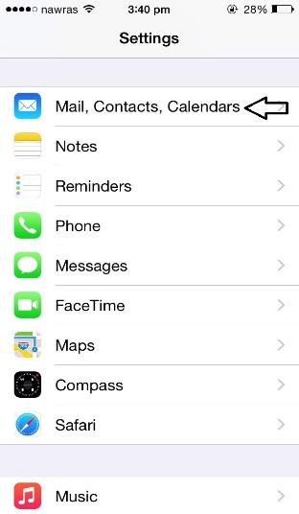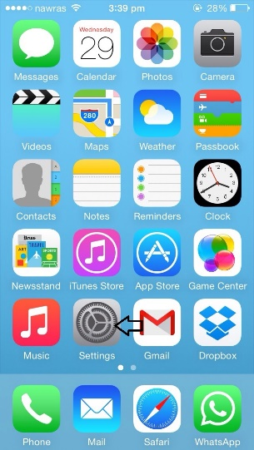

**Step 2**

**Step 3**

Select Exchange.

Select Add Account.

This step is skipped if this is the first

Email account on the phone.

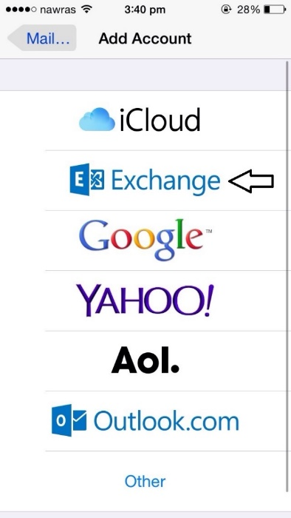

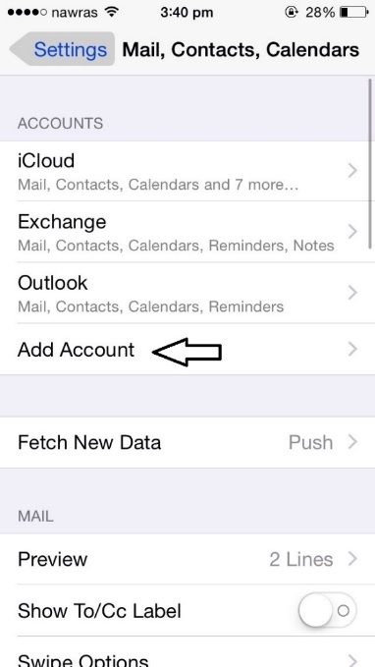

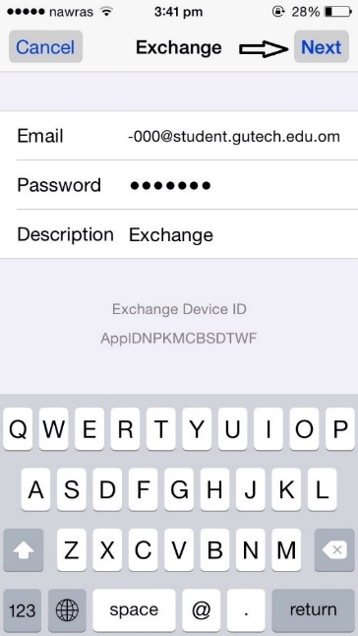

**Step 4**

In the **Email** field, enter your full email

Address (for example, **00-0000@student.gutech.edu.om**).

In the **Password** field, enter the same **password** used for your email.

In the **Description** field, enter **GUtech** (Optional)

Click Next

1. .

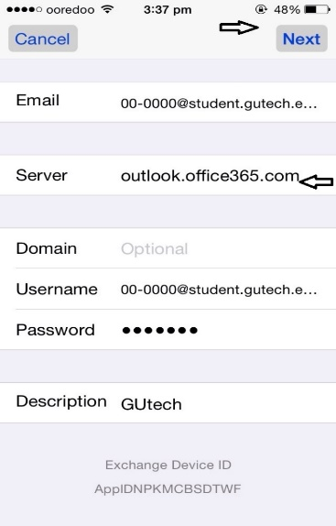

**Step 5**

In the **Server** field, enter "outlook.office365.com" (without quotes).

Click **Next**.

**Step Six**

Choose which options you'd like synchronized.

Click **Save**.

**Setting Up Your Android Mobile at GUtech Microsoft Outlook Office365**

1. From your Home screen on your device select the Email icon.

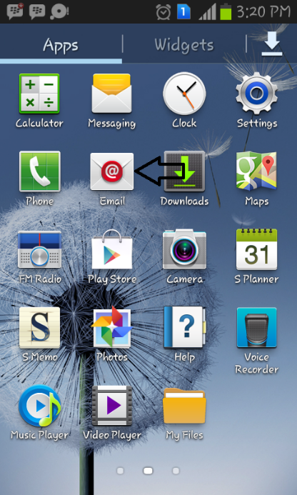

1. On the next screen enter in your full email address and in the next page the password.

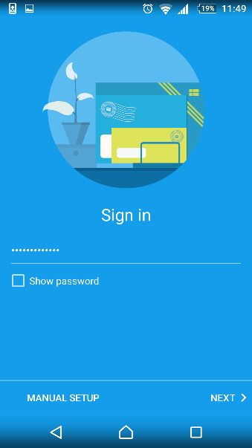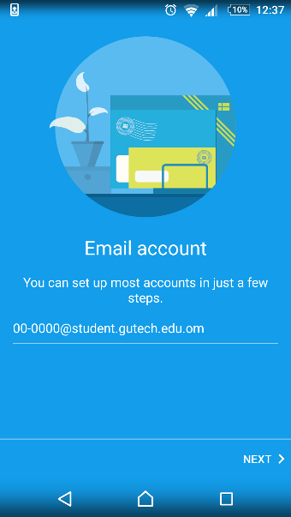

3. on the following options screen select **IMAP account**

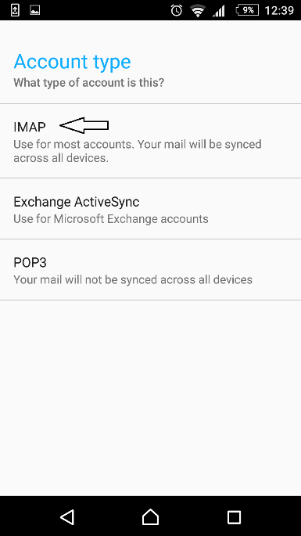

1. **Next**, in the Domain\Username field enter in your entire email address and be sure that the "Use Secure Connection (SSL)" is check and select **next** at the bottom. ( Edit Settings if the connection fails)

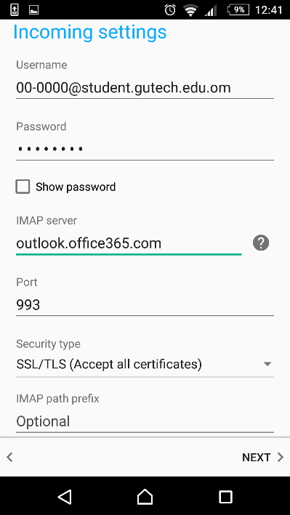

1. Change SMTP server and security type as below:

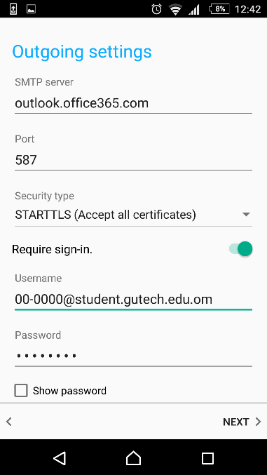

1. 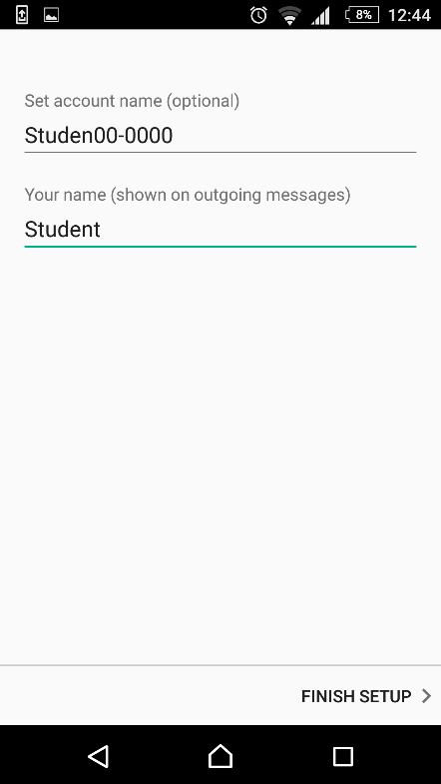Click Finish Setup and wait to load your messages.

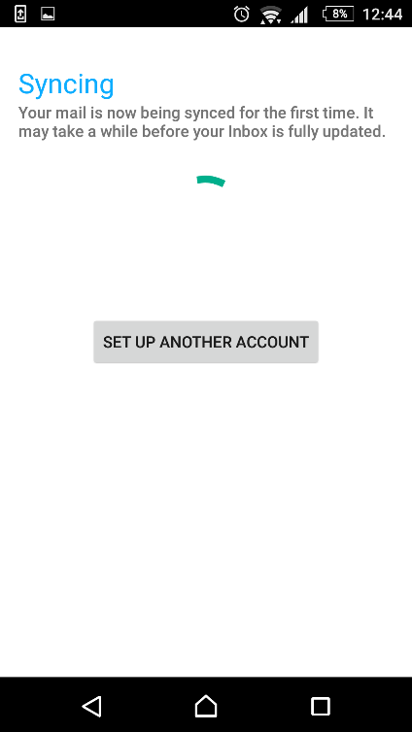

# ERP ([Enterprise Resources Planning](http://en.wikipedia.org/wiki/Enterprise_resource_planning))

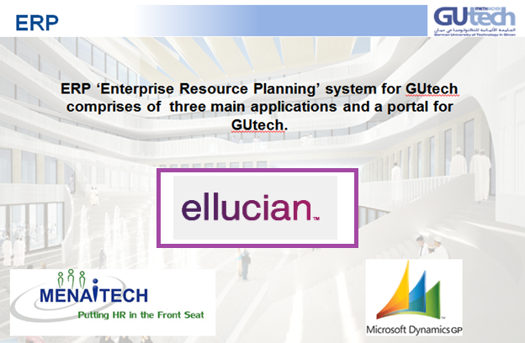

ERP system for GUtech comprises of three main applications and a portal <https://mygutech.gutech.edu.om>

1. Student information System : Ellucian Power Campus
2. HR System (Payroll & personnel mgmt) : MenaPay
3. Finance & Accounts : MSGP

# Staff/ Student ID card

A staff, student or a visitor can get an RFID enabled card for the use of below services.

* 1. 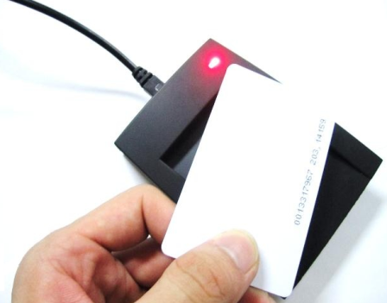Access to authorized offices and premises
  2. Access to parking (staff only)
  3. Identification
  4. Library and library self-check stations

ID cards are managed by Infrastructure department of university.

Follow the process below to receive your ID card:

**Students:**

Upon registration to university as a student, a card will be issued by Department of Registration and student affairs. Students receive the card as part of welcome kit.

For more information contact RSA.

In case if your card is damaged or misplaced, inform Department of Infrastructure and get a new card. There is a fee associated to this service.

**Staff:**

Upon enrolment in the Menapay HR system, the staff is eligible to receive his/her card. This will be issued as part of welcome kit.

In case if your card is damaged or misplaced, inform Department of Infrastructure and get a new card. There is a fee associated to this service.

*.*

For any further details contact Mr. Jamal of Infrastructure and Maintenance Unit – [jamalalbalushi@gutech.edu.om](mailto:jamalalbalushi@gutech.edu.om)

# IT STAFF

**Key contacts in ITS**

|  |  |  |  |  |
| --- | --- | --- | --- | --- |
| **Name** | **Position** | **E-Mail (@gutech.edu.om)** | **Extension** | **Mobile** |
| Mr. Jiji Tom Varghese | Head of IT Services | jiji.tom | (1080) | 92877866 |
| Mr. Mohamed Rayeesudeen | Databases Administrator & Senior Programmer | mohamed.rayeesudeen | (1085) | 97703794 |
| Mr. Nitto Varghese Tobby | IT Administrator | [nitto.tobby](mailto:nitto.tobby@gutech.edu.om) | (1086) | 96261497 |
| Mr. Mohammed Al Mushaifri | IT Executive | mohammed.almushaifri | (1087) | 99821886 |
| Ms. Iman Al Fakhari | IT Executive | iman.alfakhari | (1083) |  |
| Mr. Sulaiman Al Hoqani | IT Support Specialist | sulaiman.alhoqani | (1088) | 95284848 |
| Ms. Sahir Al Jahwari | IT Technician | sahir.aljahwari | (1088) |  |
| Mr. Omai Al Balushi | IT Technician | [omai.albalushi](mailto:omai.albalushi@gutech.edu.om) | (1088) |  |



* [Web form](http://support.gutech.edu.om/IT_TaskRegister.aspx" \t "_blank)
* Email: [IThelpdesk@gutech.edu.om](mailto:Ithelpdesk@gutech.edu.om)
* Phone: +968-2206 1088, 22061089
* Fax: +968-2206 1002

|  |  |
| --- | --- |
| **D:\Users\jose.jobby\Desktop\jiji.jpg** | |
| **Mr. Jiji Tom Varghese : Head of Department - ITS** | |
|  |  |
| **Mr. Mohamed Rayeesudeen : Database Administrator and Senior Programmer** | **Mr. Nitto Tobby : IT Administrator** |
|  |  |
| **Ms. Iman Al Fakhari : IT Executive** | **Mr. Mohammed Al Mushaifri: IT Executive** |
|  |  |
| **Mr. Sulaiman Al Hoqani : IT Support Specialist** | **Ms. Sahir Al Jahwari : IT Technician** |
| C:\Users\mohammed.almushaifri\Desktop\omai pic.JPG |  |
| **Ms. Omai Al Balushi : IT Technician** |  |

**Campus Wide application**

# ****GUtech’s Enterprise resource planning (ERP) System****

GUtech has implemented an ERP system which provides a quality oriented business system, which comprises of ERP software, information technology infrastructure, and the integration of related business units. At GUtech, the related business units are Dept. of RSA, HR and Finance.

The information below describes the software implemented for different business units:

1. **Student Information system is done on Power Campus application**

*(By Ellucian) and managed by RSA department.*

This software includes student administration and academic information.

The various modules are:

* + Admissions/Registration
  + Academic Records
  + Students grade and transcripts
  + Billing and sponsoring
  + Alumni

1. **Human recourse system is done on Mena Pay application**

*(By MenaiTech Co,) and is managed by HR department.*

This is a web based payroll application which support multi-language, multi-currency and multi-branch.

The various modules are:

* + Comprehensive employee personal file
  + Leave & vacation management
  + Employee financial data
  + Health insurance
  + Additional salaries
  + Built-in report generator

1. **Finance system is done on Microsoft Dynamic Grade Plains Application**

*(By Microsoft,) and is managed by Finance department.*

This is a comprehensive ERP application by itself. It works as a client application for various users coupled with a business portal for designated users.

The various modules are:

* + Financial management
  + Business intelligence and reporting
  + Budgeting
  + Project Accounting
  + Collaborative workspace
  + Inventory control ,asset management, purchase module

**ERP Portals**

* Power Campus Portal & Power Campus Self Service
* GP Business Portal
* Mena-Me portal (planned in 2012-13)
* Moodle
* Qwiki
* Gutech Mobile App

1. **My GUtech Portal**

The Power CAMPUS Portal, provides constituents across the campus with personalized, role-based, single sign-on access to campus information and services. Functionality we can deliver better service faster, without expending resources on custom design and development.

Portal helps us to:

* Make institutional resources easier to access
* Create personalized content and messages
* Improve collaboration and communication
* Maintain a sophisticated web presence using standards-based technologies
* <https://mygutech.gutech.edu.om>

1. **Power Campus Self Service**

Self-service is a website that allows student and staff (academic) to access information and perform routine tasks such as attendance, grade, transcripts etc.

Self Service helps:

**Staff to;**

* mark attendance
* create course homepage
* enter Grade for each course
* view class list and transcript details

**Students to;**

* view Grade report
* invite parent/sponsors to view grade
* register for new course
* do online application (to be implemented for prospective students)
* <https://myselfserv.gutech.edu.om/SelfService/Home.aspx>

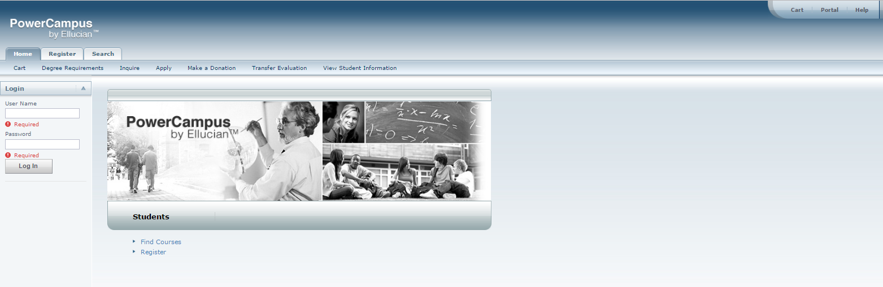

1. **GUtech Moblie Application**

* An initiative to improve the experience of students, faculty, staff, visitors, who interact with GUtech, using smartphones and tablets.
* Apple Store: <https://itunes.apple.com/us/app/gutech/id1121990707?mt=8>
* Google Play: <https://play.google.com/store/apps/details?id=com.edu.gutech.mobile&hl=en>

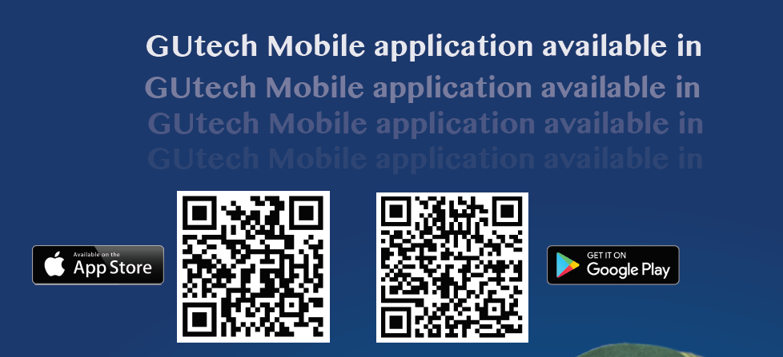

1. **Mena Me Portal**

* GUtech Staff uses Mena-me self-service portal for HR functions.
* <http://gutech-mena01/MenaLive/MenaME/main_page.php>

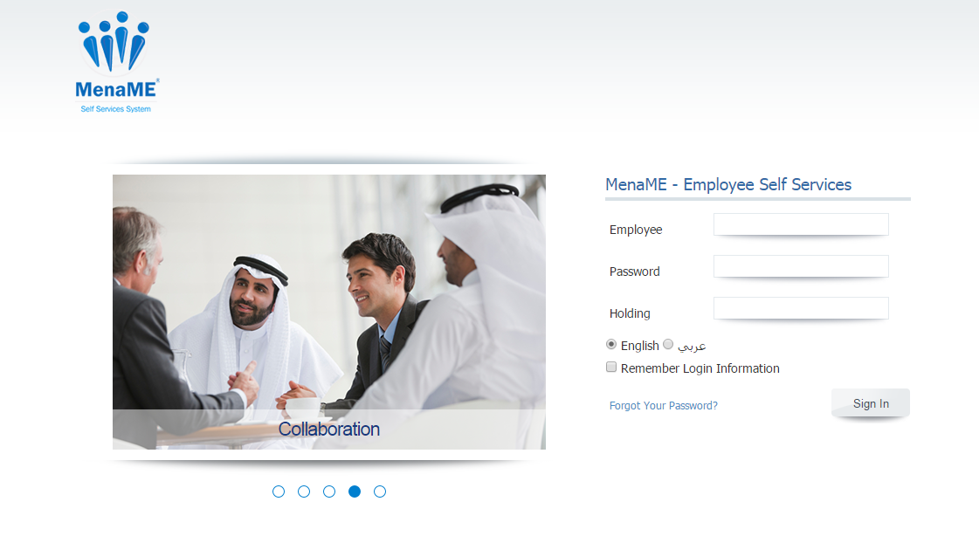

1. **IT Helpdesk Portal**

To request for IT support, logon to: <http://support.gutech.edu.om>

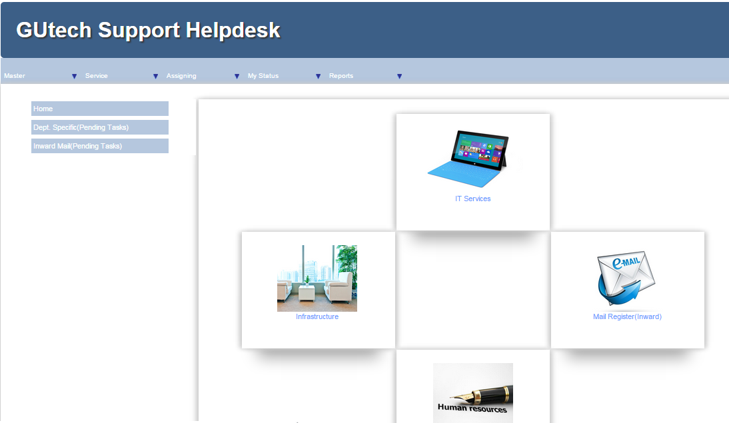

1. **QWiki Portal**

* Quality wiki is a content management system, which benefits all the members/departments to share policies, procedures, plans, guidelines etc. Each department has a separate space (called ‘web’ in Qwiki) in which the list of people, operational plans of department etc. are found.
* Link: <http://qwiki.gutech.edu.om>

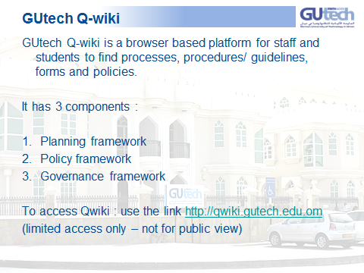

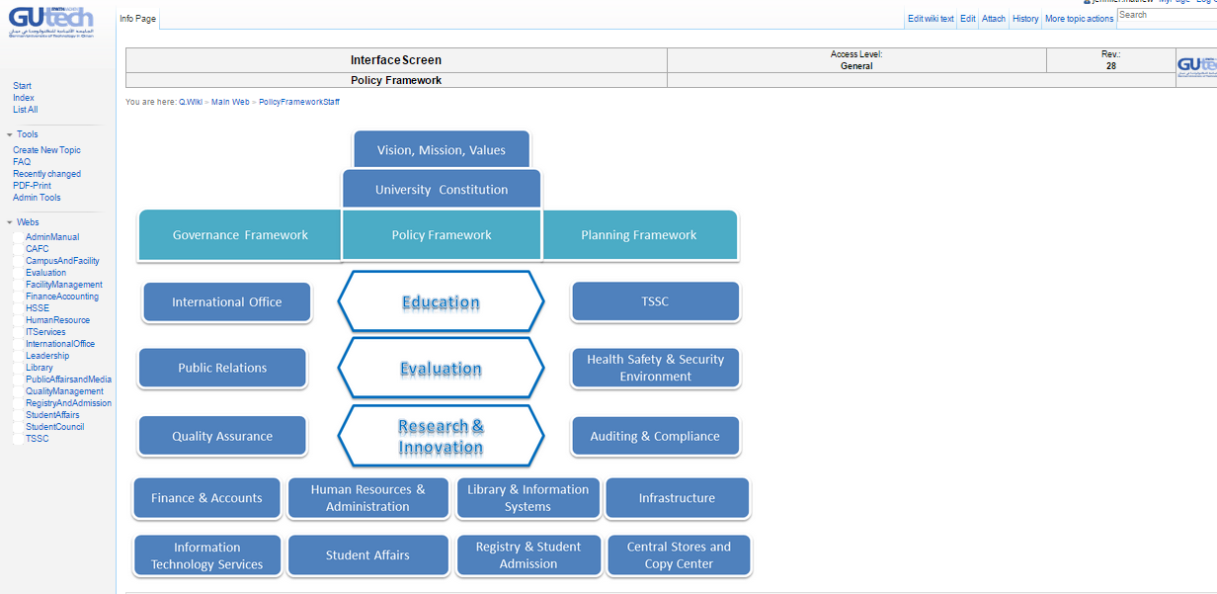

1. **Moodle E-Learning platform**

* **Login at:** <https://moodle.gutech.edu.om/moodle/login/index.php>

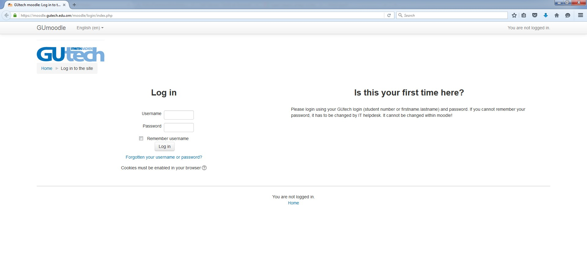

1. **GP Portal**

* Link: <https://gutech-gp01/GP>

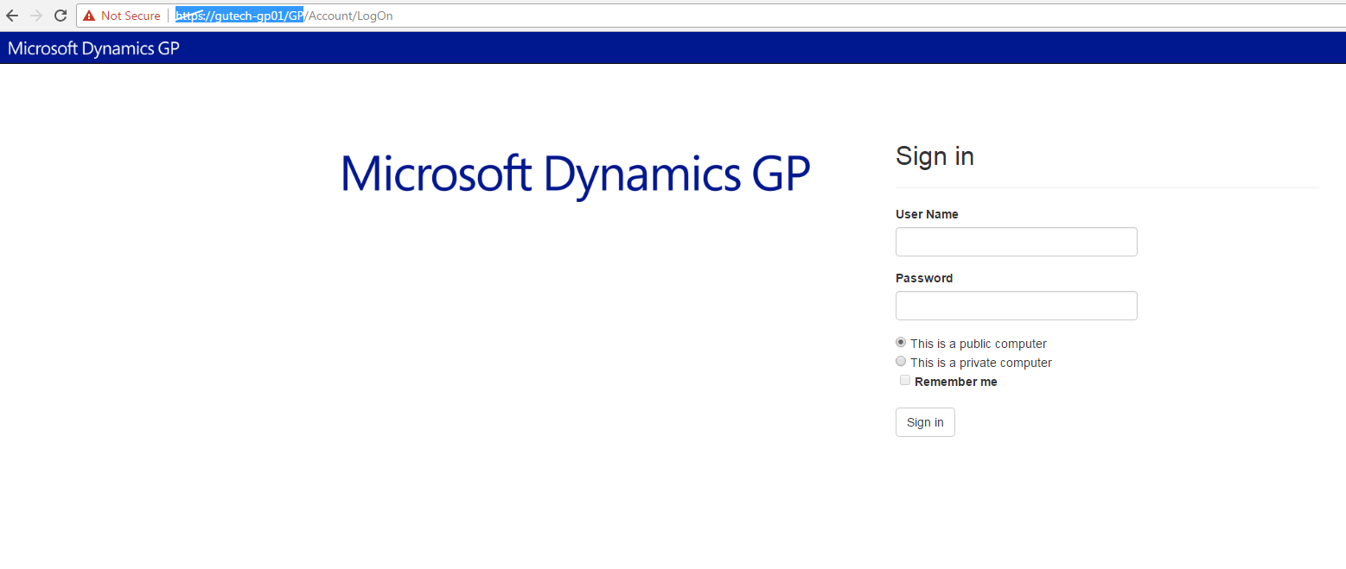

1. **TRC Portal**

**(This is research council portal, accessible for stakeholders)**

* Login at : <https://www.trc.gov.om/portal/sec/portal/default/TRESS>

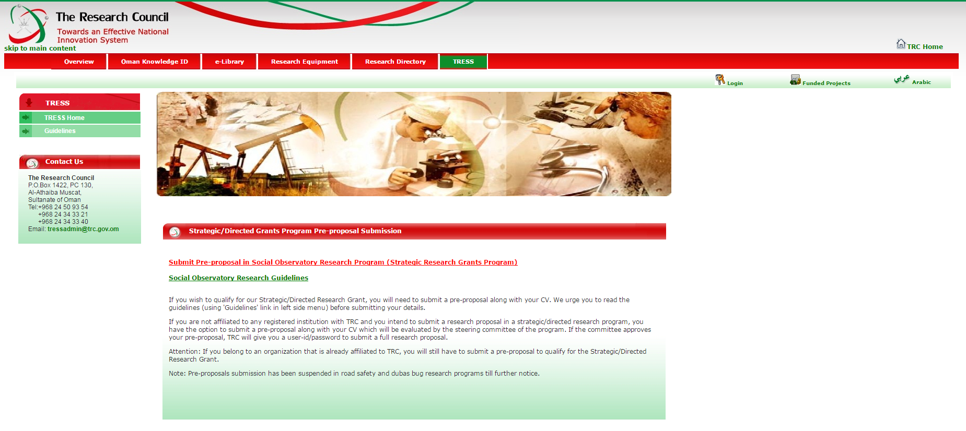

**Select German University and Proceed**

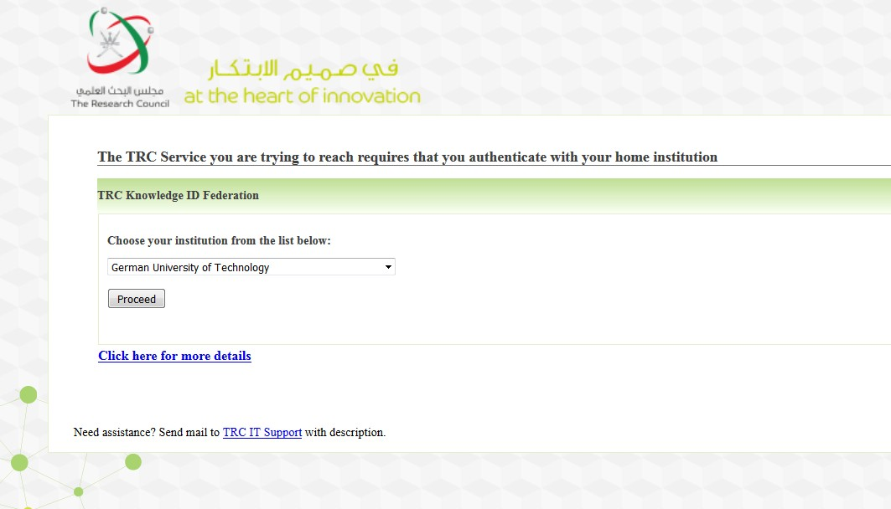

**Provide your GUtech domain user name and password**